NOTICE OF THE 2019 ANNUAL GENERAL MEETING

NOTICE IS HEREBY GIVEN that the 2019 Annual General Meeting of Triathlon Victoria will be conducted at the following time and location:
Date: Wednesday 27 November 2019
Venue: Boardroom, Sports House and by conferencing facilities (details TBA)
375 Albert Rd, Albert Park, VIC 3206 (click here for location map)
6:45pm Arrival and sign-in
7:00pm Annual General Meeting

Board Elections - At the 2019 Special General Meeting, in accordance with the Constitution, the Board declares four (4) general board positions vacant and open for nomination (2-year term).
- Board members currently in the role of President and Treasurer (Paul Stevens and Peter Guy respectively) and Amanda Green are at the end of their term and have indicated they will renominate. Cecily Schwab will resign from her position on the board creating the fourth vacancy.
- Both independent director positions (Paul Gladwell and Mary Ann Seebeck) are at the end of their terms with Paul indicating he will nominate as a general board member
Attendance, Delegates and Voting - Pursuant to Rule 13, each ‘member club’ (member that is a club) represented at the Annual General Meeting is entitled to one (1) vote. Each ‘club member’ must inform TV of the delegate (individual) attending the AGM with the voting rights for their club. This may be done by email, or using the appropriate form (attached).

Voting by Proxy - Pursuant to Rule 34.2, proxy voting is permitted at the Annual General Meeting. The appointment of a proxy must be in writing and signed by the ‘member club’ making the appointment on ‘club’ letterhead or by the form provided (attached). A notice appointing a proxy must be provided to the Chairperson, prior to, or at the commencement of the meeting.
Timeline
Date | Activity
24 October | Notice of AGM provided to members (affiliated clubs) including nomination, club delegate and club proxy forms
13 November | Nominations close for general board positions (midnight)
18 November | Circulation of nominations, 2018 AGM minutes, 2019 Annual report, incl. financials.
27 November | Annual General Meeting

Please contact me at grant.cosgriff@vic.triathlon.org.au or 03 9598 8686 for any further information.

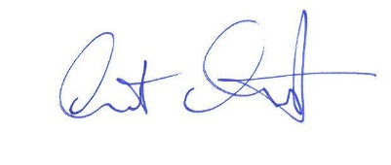
Yours sincerely,

Grant Cosgriff
Executive Director

